What does component lifecycle actually mean?

The lifecycle of a component basically encompasses the different phases that a specific component instance can go through over time.

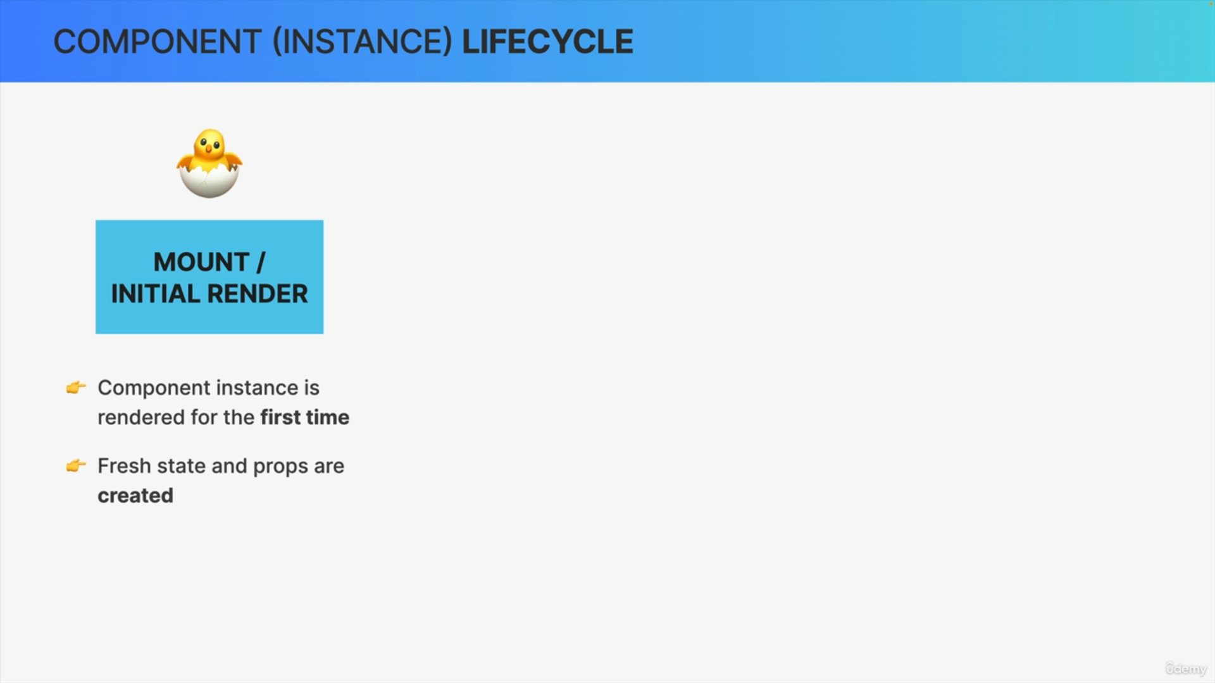

The first phase in any component's lifecycle is that a component instance is mounted which is also called the initial render. So, this is when the component is rendered for the very first time.

This is a phase when fresh state and props are created for the component instance. Therefore, I like to use the analogy that the component is born in this phase.

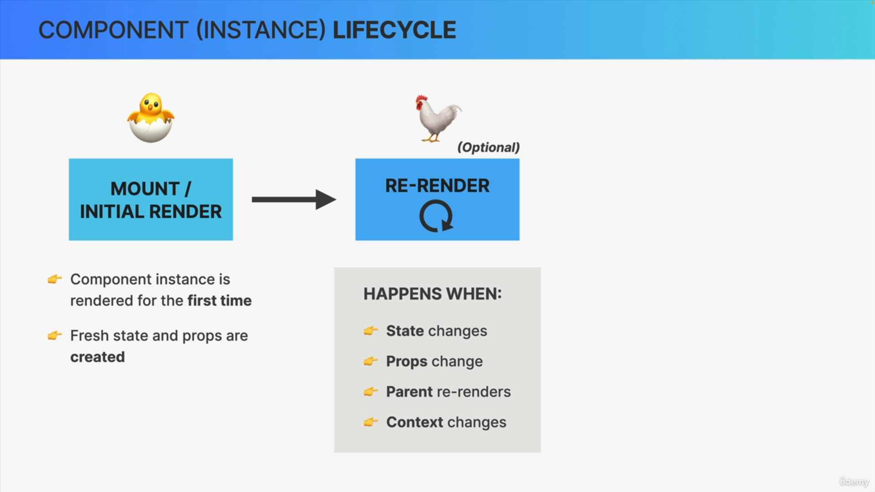

Once the component has been rendered and is on the screen, it can be re-rendered an unlimited number of times.

React application is re-rendered, whenever there is a state update. So, a component will also be re-rendered when the props that it receives change,

When its parent component re-renders, or when something called context changes.

The re-render phase is actually optional. So, it doesn't always happen in all components.

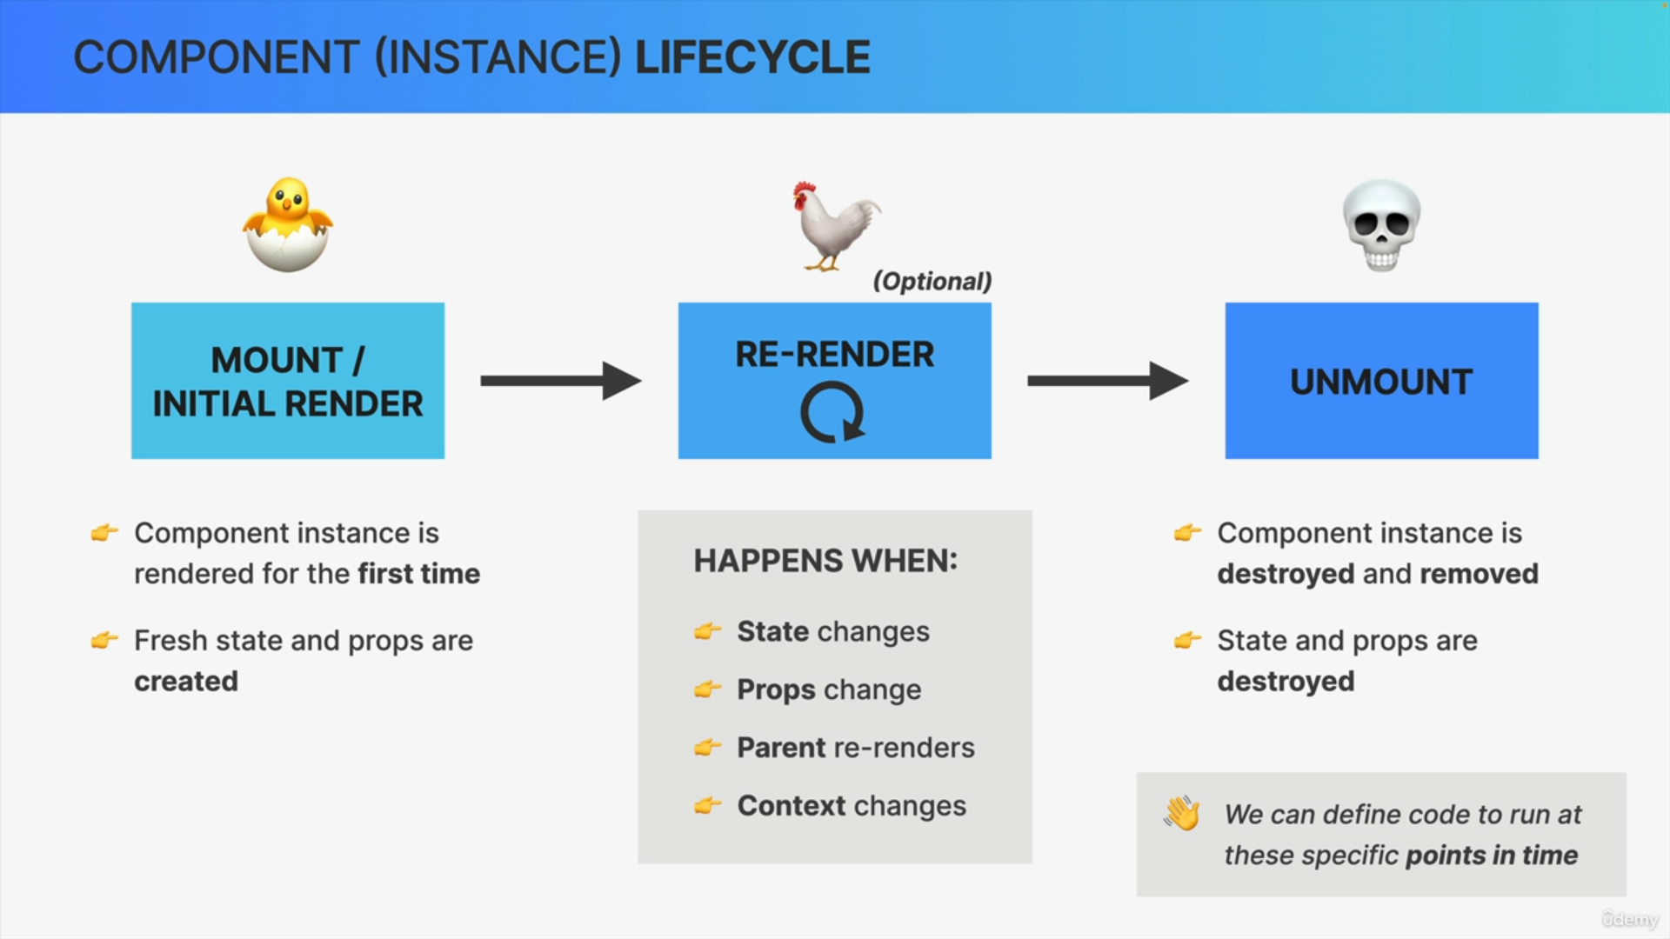

So, some components are only mounted and then unmounted, right away, which actually brings us to the next phase.

So finally, there comes a point in time, where a component instance is no longer needed. So that's when the component is unmounted. This is a phase when the component basically dies. So in this step, the component instance is completely destroyed and removed from the screen along with its state and props.

So, this can happen when users navigate to a new section or a new page of the app or when they close the app all together.

A new instance of the same component can be mounted later, but this specific instance is now gone. So, it has been unmounted.